## Multiply Number by 2

Write a function that receives a number and **prints** as result that **number** **multiplied** by **two**.

### Examples

|  |  |
| --- | --- |
| **Input** | **Output** |
| 2 | 4 |
| 5 | 10 |
| 20 | 40 |

### Hints

Create a function called solve (or some other name). As parameters, it will receive a number num.  
 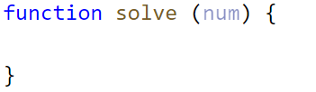

Print the result inside the function.

If you want to test your code locally, you need to call the function.